Ukulele Final Quiz Name: __________________________________

Date: ___________________________________

Name these 3 chords:

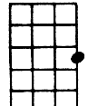
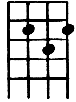
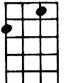
C
G
F

Fill in the blank. (HINT***Not every word from the word bank will be used).

Word bank: Four, Fretboard, Left, Eight, Tempo, Hawaii, Right, Syncopation, Six, Spain, Two

The ukulele is originally from ___________________________.

There are _____ strings on a ukulele. (How many?)

To make sound, the nylon strings are pressed against the __________________.

Traditionally, the chords are formed with the __________________ hand.

Traditionally, the strings are strummed with the _________________ hand.

Strumming chords together as an ensemble, while other ukuleles in the same ensemble are playing single note melodies, shows excellent __________________________.

The speed at which a passage of music is played is called __________________________.

Label the ukulele photo using these terms: Head, Neck, Body, Strings, Frets

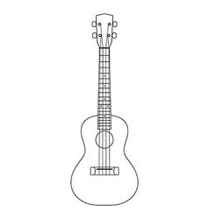

What was your favorite part about learning to play the ukulele?

